Skipily orders API
Retrieving orders via API and writing back fulfillment — for the
Connection to Shopify, Odoo or your own ERP. No second tool, no
manual transfer.

- **Endpoint:** `https://vcjwlyqkfkszumdrfvtm.supabase.co/functions/v1/orders-api`
- **Auth:** Header 'x-api-key: <your API key>' (provider portal → master data → API & integration)
- **Prerequisite:** Pro/Enterprise plan, shop active
- **Scoping:** Each key only sees its own orders.

Two integration paths (combinable)

Path | Direction | What for?
Pull (this API) | Skipily → your system | Retrieving Orders, Increment Sync (updated_since), Backfill
Push (Webhooks) | Skipily → your URL | Real-time notification of new/changed order (set webhook_url)

Recommendation for ~50 orders/day: **Webhook** for real-time + **hourly pull with 'updated_since'** as a safety net (catch up on missed webhooks).

Endpoints

### List orders
'''bash
curl "https://vcjwlyqkfkszumdrfvtm.supabase.co/functions/v1/orders-api?status=confirmed&limit=50" \
-H "x-api-key: DEIN_KEY"
```

Filters:
Parameter | Example | Purpose
Status | confirmed | pending/confirmed/shipped/delivered/cancelled
payment_status | paid | Get paid only
updated_since | 2026-06-15T00:00:00Z | Increment sync — only changed since then
created_since | 2026-06-15T00:00:00Z | only new orders
limit / offset | 50 / 0 | Pagination (max 200)
sort / order | updated_at / desc | Sorting

Single Order
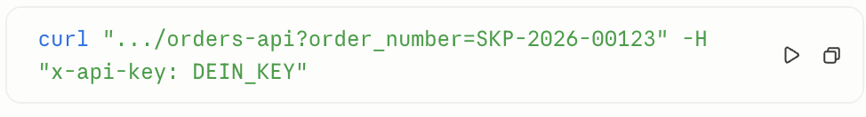

Answer (shortened)
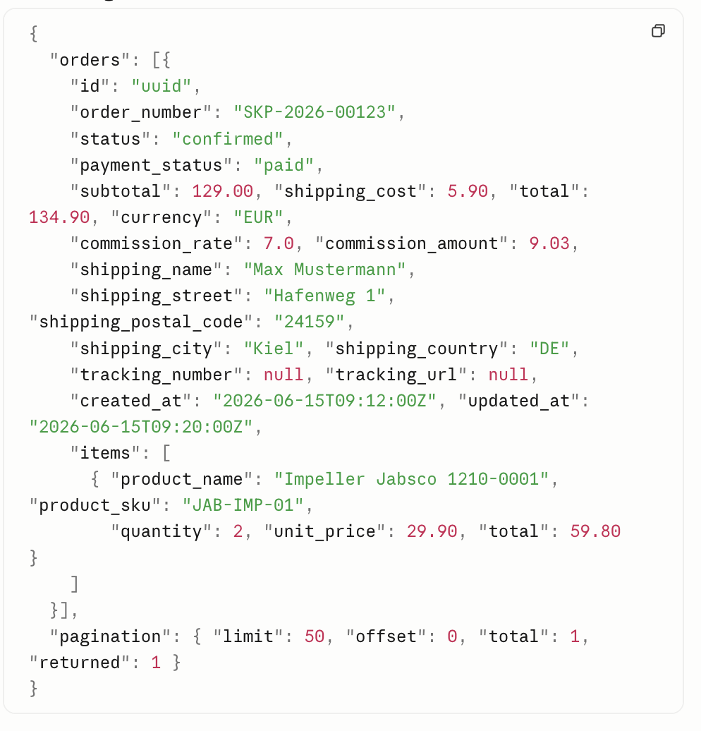

Write back fulfillment (report shipping)
When your ERP/Shopify ships, write back status + tracking — the
Buyer is automatically notified:

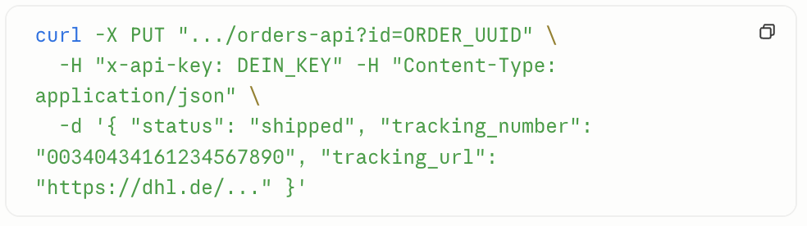
Aceppted Status: 'Confirmed', 'Shipped', 'Delivered', 'Cancelled'.

Integration Odoo
- Pull: Scheduled action, e.g. every 15 minutes: 'GET ...? updated_since=<last sync>' → create/update sale orders / pickings.
- Push back: When confirming delivery in Odoo → 'PUT ...? id=' with 'status=shipped' + tracking.
- Idempotency: 'order_number' as an external reference ('client_order_ref') → don't store duplicates.

Integration Shopify
- Mirror skipily orders via pull as Shopify orders (Order Create API), 'order_number' as 'note'/'tags'.
- Shopify-Fulfillment-Webhook → `PUT …` an Skipily mit Tracking.
- Alternatively, direct webhook reception: set 'webhook_url' in the provider profile to a Shopify flow/middleware endpoint.

Error codes

HTTP | Significance
401 | x-api-key missing or invalid
403 | Tariff too low (Pro/Enterprise required)
404 | Order not found (or does not belong to this key)
400 | invalid parameter / empty PUT

